Aus Bat Society info
Occasionally, bats may use buildings as day-time roosts or maternity sites. The normally congregate in ceilings or wall spaces where their guano may build up and cause staining and odour. These last two features are tell-tale signs of bat occupation and one may also be able to hear the bats twittering away to each other, if the colony is large enough.
How do you remove these bats without injuring or killing them? There are some relatively simple guidelines that may be followed:
It's best to remove the bats in the warmer months when they are most active and likely to leave the roost each night to forage for insects.
During October to December, many Australian bats breed and may have dependent young at that time of year. This is also a least preferred time to attempt an eviction as many baby bats may be left behind in the roost and die as a result of your activities.
If you follow this strategy step by step, you should be able successfully evict the bats:
1. Most of the bats in the colony will fly out at dusk to forage on insects in the local area. They will start to return after a few hours and then there will be intermittent arrivals and departures at the roost throughout the rest of the night. The first step is to identify where the bats are gaining access to the roost. There may be multiple access points - you need to find them all.
2. Step two is to work out a means of sealing off the access points. There are many options including expanding foam for small gaps and fly wire for exposed eaves. In some cases it may be necessary to lift the roofing iron to place exclusion netting. When you have worked out your strategy, buy the necessary materials and muster the tools so that you are ready to do the job.
3. Step three is to achieve a bat-free roost. You will need to allow the bats to exit the roost on their nightly foraging expedition and to then ensure that no other bats are left behind in the roost. If you have physical access to the roost area, you may be able to disturb remaining bats so that they leave, or another technique is to fix a sheet of plastic or similar material above the exit points and allow it to hang down over them. Exiting bats can then drop down out of the exit points but have great difficulty returning because their path is blocked by the plastic sheet.
4. Having made sure that all the bats have gone, step four is to seal up all the entry/exit points with the array of materials that you assembled in step two. Unfortunately you will probably be working in the dark! It's important however, that you have the job completed before the bats try to return. If you cant finish the work in one night, be sure to place some temporary obstructions in all of the entry points so that you can resume work the following day without fear of trapping any bats that may have returned.
5. Finally, a ver y important step that is often overlooked! Wait a few days and repeat your dusk observations again as in step one above. Bats are very good at finding alternative entrances to favourite roosts! If you do identify the annoying fact that bats are continuing to use the site, you need to repeat the above process. Be patient and you will succeed.

Bat Conservation International Info

Exclusion Guidelines
Guidelines for Excluding Bats
Our goal is to promote exclusion methods that ensure the safety of both bats and people. We understand that differing architectural structures and/or climatic conditions may require modification of the guidelines given below. Please feel free to share your ideas about these issues with us when submitting your letter of commitment. We want to encourage you to participate in the "Bats In Buildings" program and look forward to receiving your input.
All BCI's recommended exclusion professionals should be licensed by the states in which they work, be insured and use only approved exclusion methods. They should also provide the property owner with a guarantee and list of references. All written materials should be accurate and scare tactics should be avoided.
One-way devices constructed from light-weight polypropylene netting (<1/6" mesh), plastic sheeting or tube-type excluders are the preferred methods for evicting bats from buildings. Excluders should be placed at all active entry points and should remain in place for at least 5 to 7 days. These devices should be removed after the bats have been excluded, and then exclusion points should be sealed with silicone caulking, caulk backing rod, hardware cloth or heavy-duty polypropylene mesh. In some cases, sealing may require repair or replacement of old, deteriorated wood. BCI strongly recommends that exclusion professionals bat-proof the entire building and avoid spot treatments. Moving bats from one corner of a building to another does not solve the problem and may require further exclusion work is carried out at some time in the future, further disturbing the bats and the property owner.
Please note that simply waiting until the bats have flown out at night and then permanently sealing entrances shut without the use of exclusion devices, is not approved by BCI. This method often traps some bats inside the building. BCI also discourages the use of 'permanent netting' in most situations. Aerosol dog and cat repellents may discourage bat use of a particular roosting spot for periods of up to several months. They have been used effectively to prevent bats from night-roosting above porches. The spray should be applied by day when bats are not present. Aerosol repellents are not an adequate substitute for exclusion in the case of day roosts and should never be applied when bats are in a roost. For night roosts, we also recommend the use of Mylar balloons or strips of tin foil hung from roosting areas and allowed to move in the breeze.
Maternity season for bats in the US and Canada can range from May 1 through August 31, although pups have been seen as early as late April in some instances. Eviction of bats, or any activity that directly affects their roosting area, should occur before or after the maternity season, when young will not be trapped inside.
Some bats hibernate in buildings during winter months. Winter exclusions should be performed only if it can be determined that no bats are hibernating in the building. If bats are present during the winter, exclusions should be postponed until spring temperatures are warm enough for deciduous plants to leaf out and insects to again be abundant.
Ultrasonic devices, chemical repellents and smoke are not approved by BCI as effective methods to evict bats from buildings. In addition, canned spray foam is not an approved sealant for cracks and holes in most situations. It is not only unattractive, but can result in the death of bats that come into contact with it. This product should never be used when bats are still present.
Traps and relocation are not BCI-approved exclusion techniques. Removing large numbers of bats from a building may seem impressive to a customer, but is unlikely to be effective. Traps can be fatal to bats if left unattended or if overcrowding occurs. Bats have excellent homing instincts, so relocation attempts are not likely to succeed. The bats will simply attempt to return to the original capture area upon release. Capturing bats at an exclusion site is not encouraged, although capturing a single bat for species ID or removal of an individual bat from a living space are exceptions to this rule.

Do It Yourself I

New! Bat Exclusion Tube. Learn more here
NOTE: For those residing in the United Kingdom, please note that bat exclusion without prior notification to the proper authorities is a punishable offense. The proper authorities to seek guidance from include: English Nature, Scottish Natural Heritage, The Countryside Council for Wales, or the Countryside and Wildlife Branch of the Department of the Environment in Northern Ireland.
Guidelines excerpted from:
Bats in Buildings: An Information and Exclusion Guide
by Barbara French, Laura Finn and Mark Kiser

Introduction
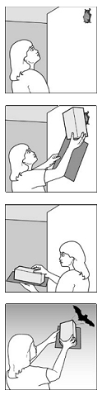
As primary predators of night-flying insects, bats play a vital role in maintaining the balance of nature. A single little brown bat can catch 1,200 mosquito-sized insects in an hour, and big brown bats are important predators of some of America's most costly crop pests. Cucumber beetles, June beetles, bark beetles, stink bugs, leafhoppers, cutworm moths, corn earworm moths, armyworm moths, termites, assassin bugs, ants, roaches, crickets, and grasshoppers are just some of the many pests known to be consumed by America's bats. Yet, bat populations are in alarming decline due to decades of unwarranted human fear and persecution.
As traditional roosts in trees and caves have been destroyed, many of North America's bats have been forced to seek shelter in man-made structures. An understanding of the habits of these beneficial animals can help solve problems that sometimes develop when bats roost in buildings. The following pages provide details about safe, effective methods for permanently evicting bats from buildings when necessary. These methods help ensure the safety of both humans and bats.
Accidental Intruders
What if you find a bat in your home?
On occasion, a solitary bat may accidently fly into a home, garage or other building through an open door or window. Such incidents often involve lost youngsters whose primary goal is a safe escape. As long as no direct contact with the bat has occurred, it can be released outside. These bats will usually leave on their own if a window or door to the outside is opened while others leading to the rest of the building are closed. Bats are rarely aggressive, even if chased, but may bite if handled. As with any wild animal, bats should not be touched with bare hands, and anyone bitten should immediately seek medical consultation.
If a bat does not leave your home on its own, its exit can be hastened by waiting until it lands, and then covering it with a small box or other container. Slip a piece of cardboard between the wall and box, slide the bat into the box, then release the bat outside. You may also catch it by hand, using leather work gloves to avoid being bitten. Keep doors and windows to buildings closed, and window screens in good repair, to prevent bats from reentering.
Where do bats roost? Bats may roost in attics, soffits, louvers, chimneys, under siding, eaves, roof tiles or shingles and behind shutters (see diagram). In sports stadiums and parking garages, bats sometimes roost in expansion joints between concrete beams. They can enter through openings as small as one-half inch in diameter (1.3 cm). Common points of entry include open windows or doors, broken or poorly-fitted screens, loose or missing shingles or tiles, places where flashing or boards have come loose and locations where pipes or wiring enter buildings. Openings often occur where walls meet the eaves at the gable ends of an attic, where porches attach to the main part of a house, or where dormers meet the roof. Other points of entry are associated with siding. For example, cracks and crevices are often created where siding forms corners, or at places where it meets windows, doors or chimneys (see diagram). Bats can sometimes be detected by the presence of black or brown stains from body oils or droppings around cracks or crevices formed by ill-fitting building materials. Bat droppings may also appear on walls, under porches or decks, or on floors beneath dilapidated ceilings. Bat droppings are dark and do not contain any white material. Although they may resemble small hard rodent pellets, bat droppings are soft and easily crushed, revealing shiny insect parts.
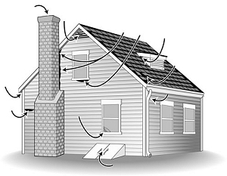
Common entry points on homes and buildings include corners, eaves and louvres.
Providing a safe exit for bats
There is little reason to evict bats from buildings where they are not causing a nuisance. However, bats should be prevented from entering human living quarters. This can be accomplished by inspecting the inside of a building for small openings through which bats could enter. All openings connecting the attic or other roosting areas to inside living quarters should be sealed, although entry points on the outside of the building should be left open, allowing bats to exit. Draft-guards should be placed beneath doors to attics; electrical and plumbing holes should be filled with steel wool, caulking or weatherstripping. Bats have small teeth for eating insects; they do not gnaw through wood or other building materials like rodents. Caulking, flashing, screening or insulation can be used to seal most openings on the inside. Expanding urethane foam products should not be used to seal cracks where bats are active, because they can become caught in it. Caulk should also be applied early in the day so that it has time to dry before bats emerge in the evening.
In some instances, noise or odors from large colonies of bats can become a nuisance. When bats must be evicted from a building, netting or tubes that function as one-way valves must be placed over the openings bats use to enter and exit. These one-way valves allow bats to leave, but not reenter the building. Valves may be constructed from lightweight plastic netting (1/6 inch-0.4 cm-or smaller mesh), or plastic pipes or tubes. These exclusion devices should be left in place for five to seven days to ensure all bats have exited. It is not appropriate simply to wait for bats to fly out at night and then seal openings. Not all of the bats leave at the same time, and some bats may remain inside all night. Take weather conditions into consideration when deciding how long to leave the netting or tubes in place; there may be evenings (such as during storms), when no bats exit.
Bats often roost in buildings seasonally, including during maternity periods, and exclusions should not take place until young bats are able to fly. After the young are old enough to fly, all bats can be excluded. The maternity season begins as early as mid-April in the southernmost U.S., mid-June in the northern U.S. and Canada. Young bats are flying and exclusions can resume by late August. In late fall most house-dwellings bats either migrate to warmer climates or enter caves or abandoned mines to hibernate. However, a few species can hibernate in buildings, and in the mildest climates, they may even remain active year-round. If bats are present in cold regions during the winter, exclusions should be postponed until spring when they emerge to feed.
Exclusion is the ONLY effective solution for permanently removing bats from buildings. Trapping and relocating is ineffective since bats have excellent homing instincts and simply return, even when released at great distances. The use of pesticides against bats is illegal and counterproductive. Poisoning greatly increases the likelihood of bats coming into contact with people and pets.
Naphthalene, the active ingredient in moth balls, and ultrasonic devices are often promoted as bat repellents. However, ultrasonic devices are ineffective against bats, and to be effective, naphthalene must be used in such large quantities that it poses a significant health hazard to humans.

Do It Yourself II

Using Netting to Exclude Bats
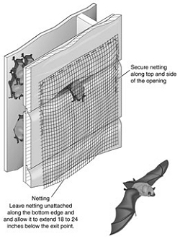
Bats sometimes enter buildings through openings on smooth surfaces of exterior walls or through louvers. In such cases, plastic or lightweight, flexible netting with 1/6 inch (0.4 cm) mesh or smaller, should be secured to the building along the top and sides of the opening as shown in the diagram. It should extend 18 to 24 inches (46 to 61 cm) below the bottom edge of the opening and should remain in place for a minimum of five to seven days to ensure all bats have exited. Then, openings should be permanently sealed with silicone caulking, caulk backing rod, hardware cloth, or heavy-duty netting. In some cases, sealing may require repair or replacement of old, deteriorated wood. When bats are using multiple openings to exit and enter, exclusion material should be placed on each opening unless it can be determined with certainty that all areas used by the bats are connected. If so, some openings can be sealed as described above, and netting can be placed over the openings used by the most bats. Even when all roosting areas are connected, bats will sometimes refuse to use alternative exits. In this case, exclusion material must be installed over all exits. After this has been done, watch to make sure the bats are able to exit safely. If they do not appear to be exiting, or appear to be having trouble doing so, make adjustments or add new valves as needed.

Using PVC pipe or Empty Caulking Tubes to Exclude Bats
There are a number of situations in which tubes work best as bat exclusion devices. Examples include openings used by bats on buildings constructed from materials that do not create smooth exterior walls, such as those found on brick or stone houses, and log cabins. Tubes also work best for holes located at corners where walls meet and on horizontal surfaces such as soffits. Exclusion tubes should have a 2-inch (5 cm) diameter and be approximately 10 inches (25.4 cm) in length. Exclusion devices can be made from PVC pipe or flexible plastic tubing. According to Laura Finn of Fly by Night, Inc., empty caulking tubes work well for this purpose. When using caulking tubes, both ends must be cut out. Use of a flexible plastic tube makes it easy to either squeeze one end of the tube so that it fits into a crevice, or cut one end of the tube into flaps that can be fit over an opening and stapled, nailed, or taped to the building (see diagram). Bats are unable to cling to the smooth surface of these tubes. Do not let the tube project more than 1/4-inch (6 mm) into the opening, ensuring that bats can easily enter the tube to exit. Caulking tubes must be thoroughly cleaned before use to prevent bats from sticking to wet caulk and because dried caulk creates a roughened surface, making it possible for bats to re-enter. Once the tube has been inserted over the hole, a piece of light weight, clear plastic can be taped around the end of the tube that projects to the outside (see diagram) to further reduce the likelihood of bats reentering, though this is typically not necessary.

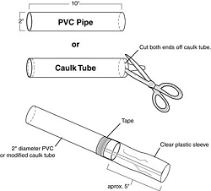
Plastic sleeves collapse on themselves, preventing bats from reentering once they have crawled out through the tube. After the tube has been inserted into or over the opening used by bats, any spaces between the outer rim of the tube and the building must be sealed shut. Be sure also to seal shut any other openings in the building that bats could use to reenter. Leave the tube in place for a minimum of five to seven days to ensure all bats have exited. After the bats have been excluded, the tube should be removed and the opening permanently sealed.
Some concrete parking garages have lengthy crevices used by bats. Multiple exclusion tubes will need to be placed every few feet along the length of each crevice; spaces between the tubes should be closed with heavy-weight (1/6 inch mesh) netting (see diagram). Fold the netting so that it fits into the crevice, and caulk it in place as shown in the diagram. The same procedure can be used in lengthy crevices created where flashing has pulled away from a wall.
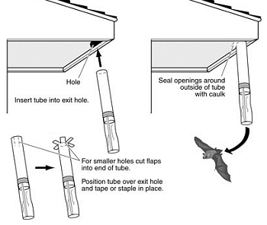
Plastic tubes also work best for excluding bats from under Spanish (clay) or concrete roofing tile. Bats typically enter through open ends of the tiles on the lowest row, or through openings created where tiles overlap one another. Observe the building when bats fly out in the evening to determine which openings they use. Exclusion tubes should be placed in these openings (see diagram). Multiple exclusion tubes are often needed to exclude bats from problem roofs. Collapsible plastic sleeves should also be attached to the ends of the tubes. Heavy weight netting can be folded and inserted into openings where tiles overlap (see diagram).
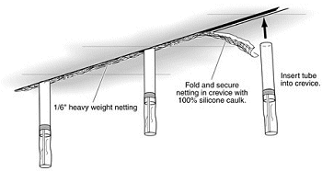
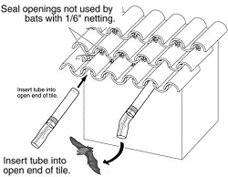
Tiles are sometimes temporarily removed to replace a layer of tar paper. When this is done, a layer of coarse fiberglass batting can be put over the tar paper and under the tiles. Constantine (1979) found that the fiberglass layer repelled bats, although he recommended against use of batting within 6 inches (15 cm) of open tile ends to prevent birds from pulling it out for nesting material.
Bats may also enter a building through spaces beneath corrugated or galvanized roofing sheets. These roofs can be sealed with a variety of materials such as caulk backing rod during months when bats are not present, or after they have been excluded from a building by use of exclusion tubes.
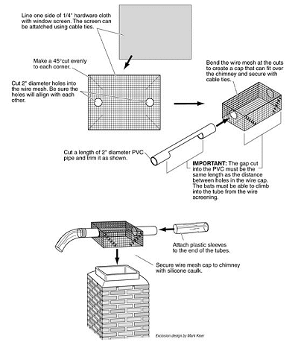
Special modifications may be needed when bats roost in chimneys or in separations between chimneys and roofs. If bats are roosting inside the chimney, construct a wire cage from 1/4-inch hardware cloth lined with window screen. A section of PVC pipe can be cut and then inserted through holes cut into the sides of the wire cage (see diagram). Although bats are able to simply drop down and out of a vertically placed tube that extends below the roost, they are not able to grip the slick surface to crawl out if the tube extends upward above the roost. Therefore, the tubes should project horizontally or down. A collapsible plastic sleeve should be placed over the ends of all exclusion tubes used on chimneys. Once the bats have been excluded, a chimney cap should be installed.

